First Increment Report
This document is a report of first iteration of work performed on the Travel Guide Mobile App. This App proposes to implement various web services into single App. The document emphasizes on the pictorial representation of the application using different implementations which gives an insight on internal system. This document intends to provide an overall description of the project named “Travel Guide” in detail.
The main outcome of the first increment is the high and low level designs of the App. As of current state we have not deviated from our initial proposal that we submitted earlier. We have taken care of the implementation of Class Diagrams and Sequence Diagrams which showcase the flow of our application. The blueprint of the application is generated using the Wireframes and are available in this document. The iconic view is represented using the Mockups.
The initial development process include the Login Page using Facebook and Google Plus API’s and completed the Unit Testing of the login module. The other page include the Home Page where we have covered the profile part and design of the functionalities which we are going to implement in the next phases.

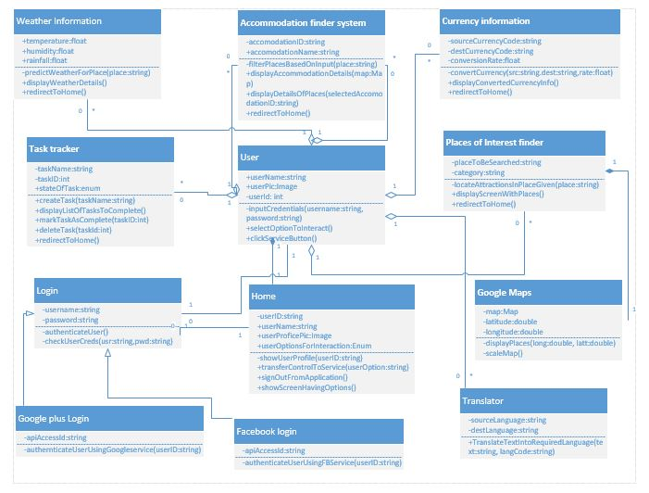
Figure 1
Figure 1 demonstrates a class diagram which explains High Level Design Architecture of the System.

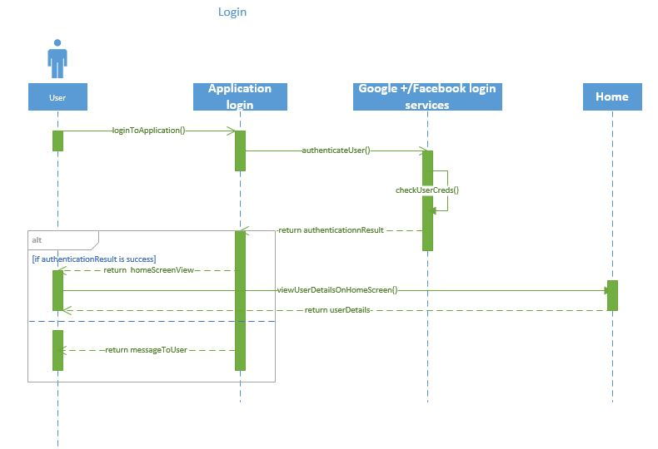
Figure 2
Figure 2 demonstrates a sequence diagram about how a user can Login to the App by using different Sign In options like Facebook, Google+.
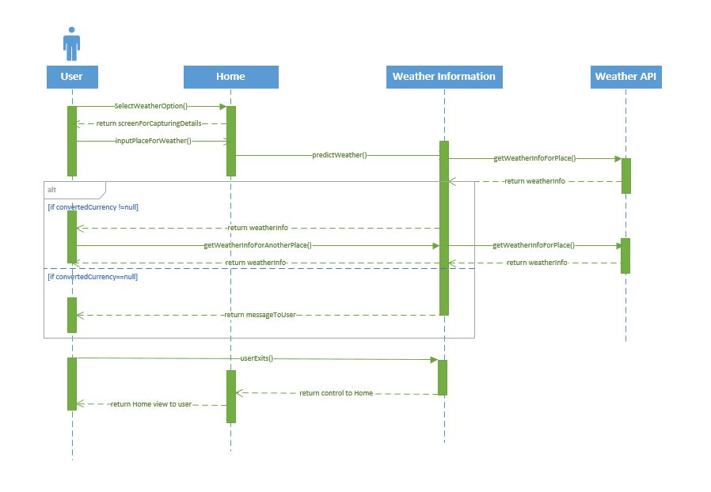
Figure 3
Figure 3 demonstrates a Sequence diagram about how a user can get the Weather of a particular location of user’s choice.

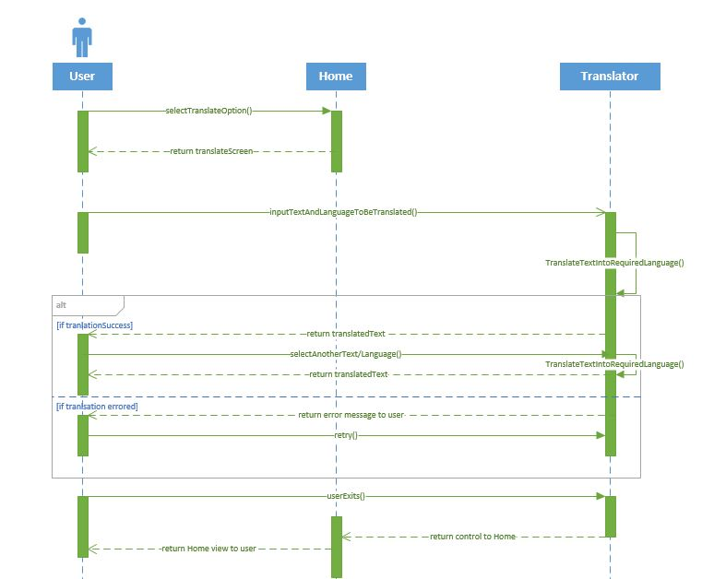
Figure 4
Figure 4 demonstrates a sequence diagram about how a user can use this App to translate the text from a Language to a Language of user’s choice.

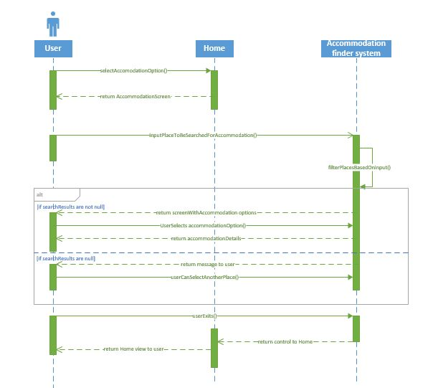
Figure 5
Figure 5 demonstrates a sequence diagram about how a user can get the Accommodation details of a particular location of user’s choice.

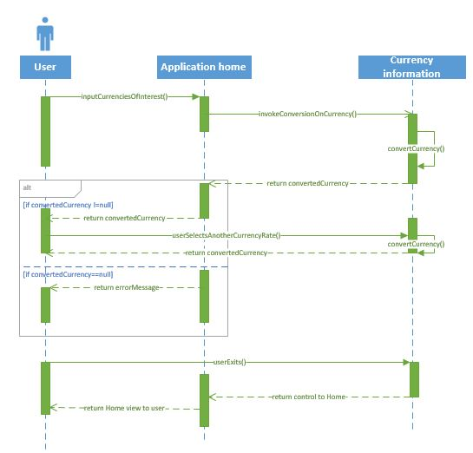
Figure 6
Figure 6 demonstrates a sequence diagram about how a user can get the currency rates of the Specified countries.

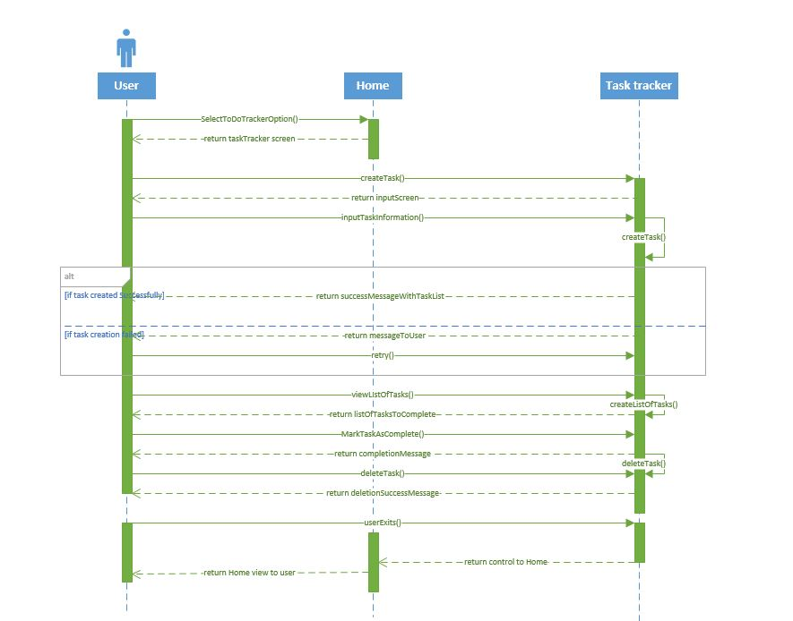

Figure 7
Figure 7 demonstrates a sequence diagram about how a user can create task.

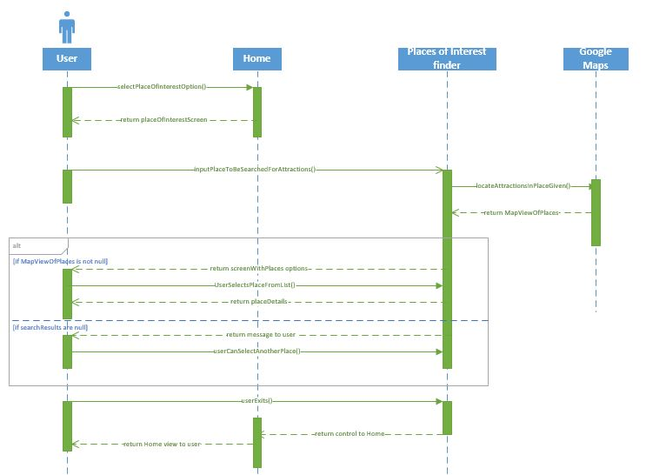

Figure 8
Figure 8 demonstrates a sequence diagram about how a user can get the places around a particular location of user’s choice.

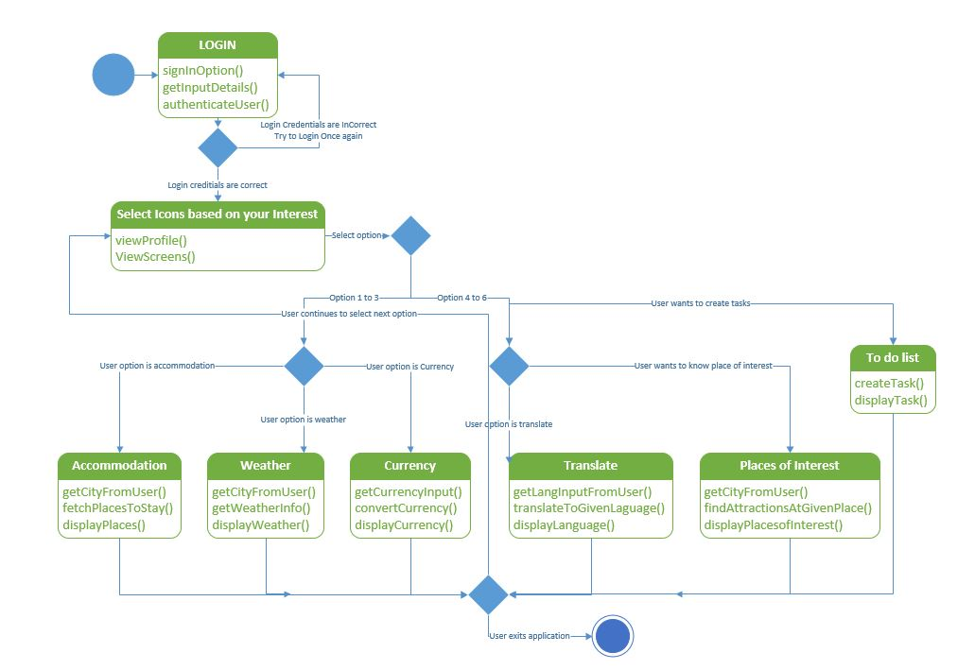
Figure 9
Figure 9 demonstrates a state diagram which explains High Level Design Architecture of the System.
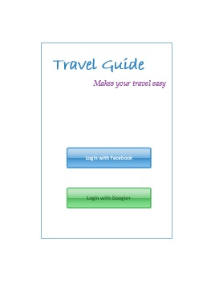
Figure 10
Figure 10 represents the startup screen for the APP.

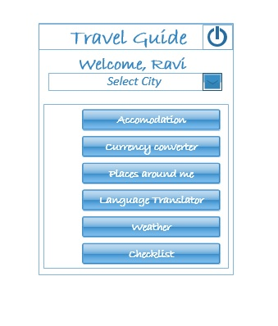
Figure 11
Figure 11 represents a wireframe for Homepage.
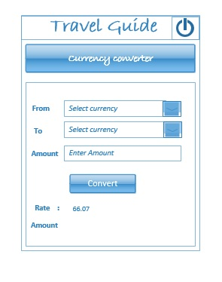
Figure 12
Figure 12 represents the Currency Converter Screen.
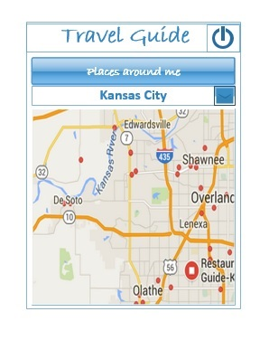
Figure 13
Figure 13 represents the Wireframe for Places of Interest Screen.
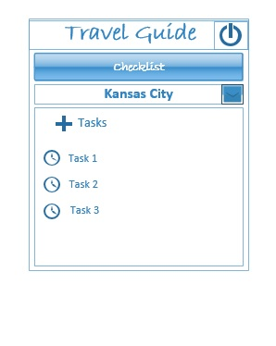
Figure 14
Figure 14 represents the wireFrame of CheckList Screen.
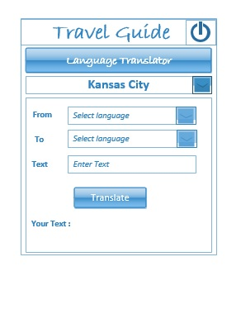
Figure 15
Figure 15 represents the WireFrame for Language Translator Screen.

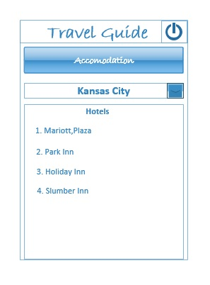
Figure 16
Figure 16 represents the WireFrame of Accomodation Finder Screen.
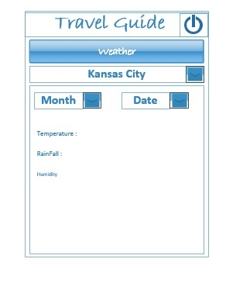
Figure 17
Figure 17 represents the WireFrame of Weather Screen.
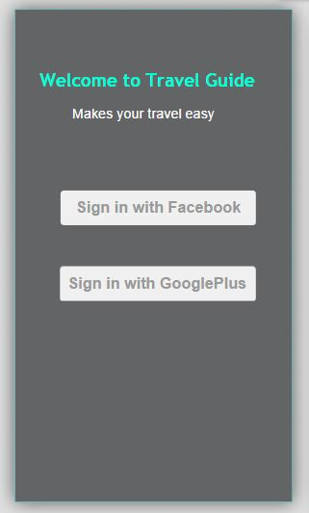
Figure 18
Figure 18 represents the Mockup for Login Screen.

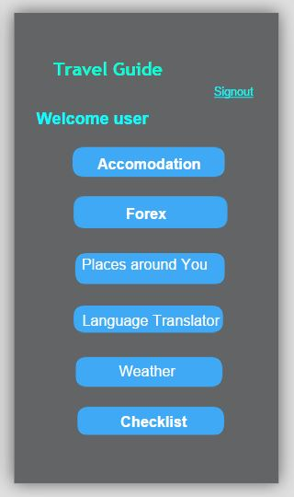
Figure 19
Figure 19 represents the Mockup for Homepage Screen.

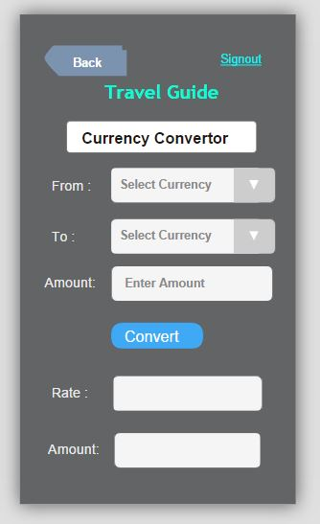
Figure 20
Figure 20 Represents the Mockup for Currency Converter Screen.
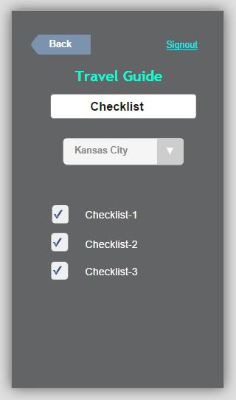
Figure 21
Figure 21 represents the Mockup for Checklist Screen.
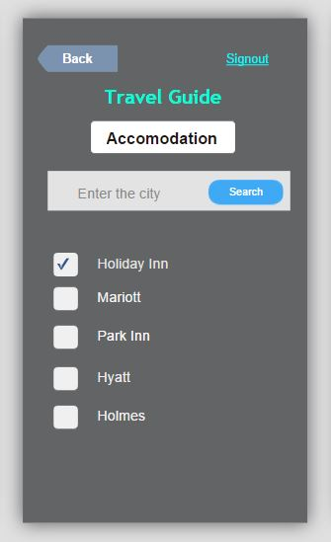
Figure 22
Figure 22 represents the Mockup for Accommodation Finder Screen.
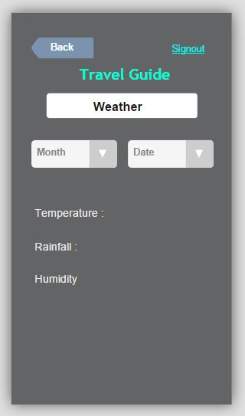
Figure 23
Figure 23 represents the Mockup for Weather Screen.

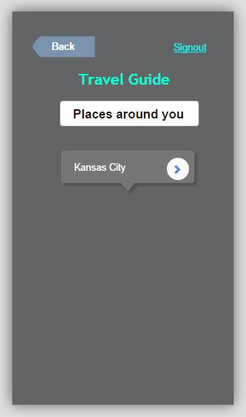
Figure 24
Figure 24 represents the Mockup for Places of Interest Screen.
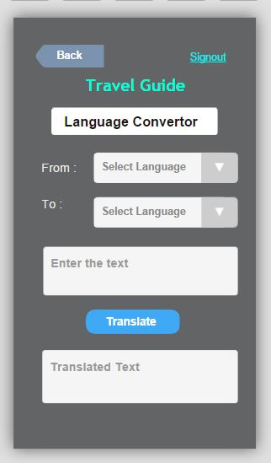
Figure 25
Figure 25 represents the Mockup for Language Translator Screen.

